# I. ESAI (40%)

1. **(20%) Mandiri** - Jelaskan yang disebut dengan self-plagiarism! Menurut Anda, apa saja faktor yang dapat menyebabkan munculnya self plagiarism? Berikan contoh paper dalam area ilmu komputer yang memiliki indikasi self-plagiarism, serta berikan penjelasan indikasi self-plagiarism pada contoh Anda.

**Jawaban:**

**Self plagiarism**

➔ Adalah **menyalin makalah penelitian Anda sendiri yang telah Anda lakukan di masa lalu**. Ini **bisa berupa beberapa baris atau gagasan yang pernah Anda gunakan sebelumnya**.

➔ Dalam self plagiarism, **hal-hal seperti penerbitan dua makalah identik juga termasuk yang disebut duplikat publikasi**.

➔ **Meskipun kita menyalin karya kita sendiri**, itu **tidak menolak fakta bahwa kita harus belajar atau memahami sesuatu yang baru dengan setiap makalah penelitian**.

**Faktor-faktor yang dapat menyebabkan plagiarisme diri dalam makalah penelitian:**

* 1. Ketika saya menerbitkan makalah penelitian, makalah itu milik jurnal yang saya terbitkan. Jadi jika saya menggunakan beberapa kata atau kata-kata sendiri tanpa izin dari jurnal kita dapat menyebabkan plagiarisme diri untuk diri kita sendiri.
  2. Mengambil ide dari makalah penelitian sebelumnya dan membangun makalah penelitian baru berdasarkan itu.

**Area yang memiliki indikasi plagiarisme sendiri dalam ilmu komputer adalah “Algoritma Perbandingan”**. **Karena banyak makalah penelitian** tentang ilmu komputer **tentang mengurangi kompleksitas suatu algoritma**.

Contohnya suatu Algoritma Perbandingan pada awalnya memiliki kompleksitas O(n^2), lalu pada perubahan dan perkembangan selanjutnya, kompleksitas menjadi O(log(n), maka kompleksitas menjadi semakin kecil dan proses menjadi semakin cepat.

1. **(20%) Mandiri** - Jelaskan apa yang dimaksud dengan novelty pada sebuah jurnal! Berikan contoh novelty dari 2 paper referensi yang digunakan dalam penelitian Anda (pastikan paper yang digunakan sebagai contoh berbeda pada setiap anggota kelompok) serta berikan penjelasan mengapa bisa Anda katakan bahwa paper tersebut memiliki unsur novelty. Note: lampirkan paper yang digunakan sebagai contoh ketika mengumpulkan jawaban Anda.

**Jawaban:**

**Novelty**

➔ **Merupakan suatu kebaharuan dari suatu hal yang pernah dibuat, terjadi, atau tersedia**.Kemajuan pesat dalam dua dekade terakhir karena munculnya dan aksesibilitas teknologi baru yang memungkinkan berbagi barang dan data. Akibatnya, **mungkin sulit untuk menemukan topik yang tidak diketahui atau tidak tersedia literatur**. **Namun masih ada banyak ruang untuk kemajuan**.

➔ **Juga bisa terletak pada kontradiksi dengan sesuatu yang dilaporkan sebelumnya**. Survei literatur menyeluruh termasuk analisis makalah penelitian dan paten perlu dilakukan pada topik yang menarik **untuk memastikan bahwa ada beberapa hal baru yang terkait dengannya**. **Variasi dalam metodologi yang dilaporkan sebelumnya yang menghasilkan hasil yang bervariasi juga dapat dianggap sebagai NOVELTY**.

## 2 Paper Referensi yang memiliki unsur Novelty:

1. [8] Nasrollahi, Kamal, Sergio Escalera, Pejman Rasti, Gholamreza Anbarjafari, Xavier Baro, Hugo Jair Escalante, and Thomas B. Moeslund. (2015) "Deep learning based super-resolution for improved action recognition." In Image Processing Theory, Tools and Applications (IPTA), 2015 International Conference on, pp. 67- 72. IEEE. DOI: 10.1109/IPTA.2015.7367098

**LINK:** https://scihub.wikicn.top/https://ieeexplore.ieee.org/abstract/document/7367098

**Judul Paper:** Deep Learning based Super-Resolution for Improved Action Recognition

**File PDF Paper ini sudah saya berikan di ZIP-Nya, KLIK sesuai Judul Paper-Nya**

**Alasan Mengapa Mengandung Unsur Novelty:**

1. **Menggunakan Algoritma Resolusi yang sudah ada**

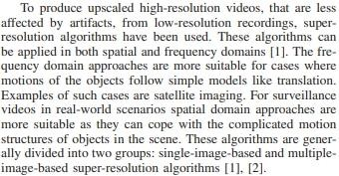

1. **Menjelaskan Tantangan dari Algoritma yang sudah ada diterapkan di topic mereka**

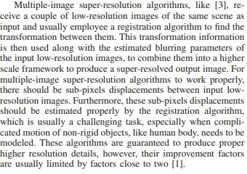

1. 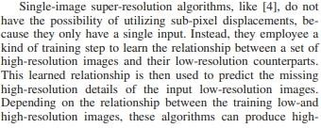**Menjelaskan Kelebihan dan Kelemahan Algoritma yang digunakan**
2. 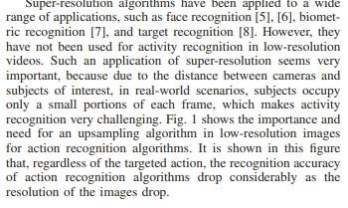**Algoritma banyak digunakan di berbagai ruang ligkup aplikasi**
3. **Menggambarkan perkembangan sistem dari algoritma yang sudah ada**

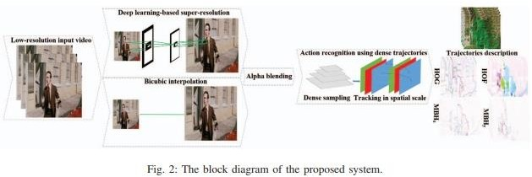

1. **Memperlihatkan Bukti Perbedaan dengan Hasil yang mudah dipahami**

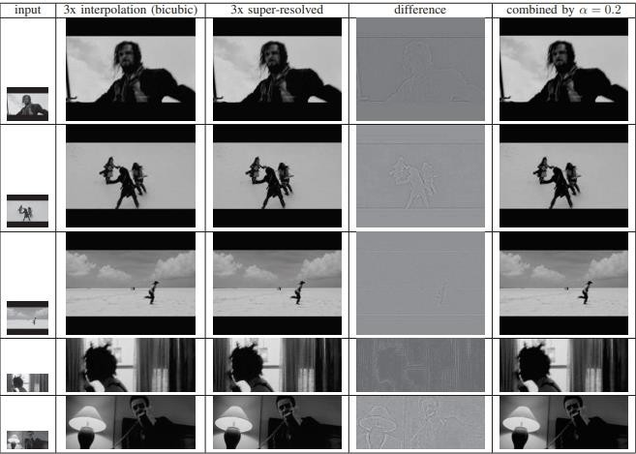

1. [9] Savioja, Lauri, Akio Ando, Ramani Duraiswami, Emanuel AP Habets, and Sascha Spors. (2015) "Introduction to the issue on spatial audio." IEEE Journal of Selected Topics in Signal Processing 9, no. 5: 767-769. DOI: 10.1109/JSTSP.2015.2447112

**LINK:** <https://ieeexplore.ieee.org/document/7154533>

**Judul Paper:** Introduction to the Issue on Spatial Audio

## File PDF Paper ini sudah saya berikan di ZIP-nya, KLIK sesuai Judul Paper-nya Alasan Mengapa Mengandung Unsur Novelty:

1. 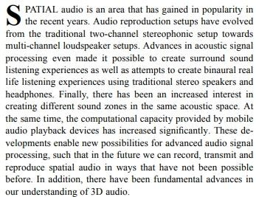**Topik ini sudah popular beberapa tahun lalu**
2. 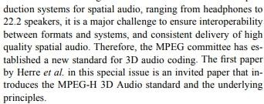**Sudah banyak Paper menjelaskan Standard Audio**
3. 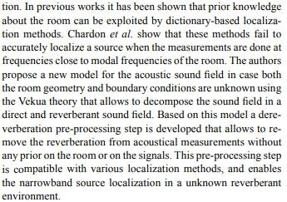**Sudah ada Paper Sebelumnya mengenai topik ini**
4. **Menggunakan referensi paper mengenai Wireless Communication**

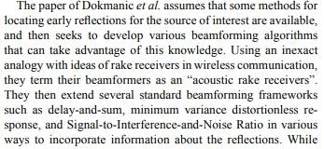

1. **Menjelaskan ada teknik tradisional, dan solusi modern untuk perkembangan zaman**

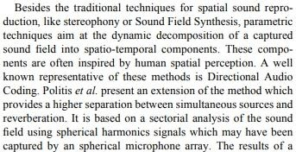

Image Analysis With R Programming

# LINK VIDEO PRESENTASI:

<https://youtu.be/rZwOXU359yI>

Aldo Jonathan Handaka Computer Science Binus University Jakarta, Indonesia

[aldo.handaka@binus.ac.id](mailto:aldo.handaka@binus.ac.id)

Evan Edbert Computer Science Binus University Jakarta, Indonesia

[evan.edbert@binus.ac.id](mailto:evan.edbert@binus.ac.id)

Aeron Mitchell Computer Science Binus University Jakarta, Indonesia

[aeron.mitchell@binus.ac.id](mailto:aeron.mitchell@binus.ac.id)

Edward Computer Science Binus University Jakarta, Indonesia

[edward007@binus.ac.id](mailto:edward007@binus.ac.id)

*Abstract*— The R programming language excels at facilitated assignments. It is broadly utilized as a high level, free and open source language which is re-mark ably unique, deciphered, scripting and multi-world view. It additionally underpins object situated programming highlights and can be utilized as a general purpose programming language. R is simpler to learn and has more straight forward linguistic structure when contrasted with C, C++ and Java. R is similarly popular for work area based applications. The ﬁelds where R truly sparkles in are information science and machine learning, numeric, representative computations. Also, it is utilized in different ﬁelds like Image processing, Games, Web improvements and Big Data Analytics. Picture preparing with R is an exceptionally efﬁcient and viable procedure for doing tasks such as dissecting the digitization of the pictures to extract the required data. A few activities such as improving the quality, upgrading, zooming, blurring, inverting the picture, composing content on the images, greyscale, performing picture rebuilding, recovering, etc. is conceivable with R. Here’s the challenge; given two images, determine if one image is a subset of the other image. This will be valuable for solving this present reality undertakings and procedures in a very effective way.

***Keywords—image, analysis, subset, R Programming, processing***

many of daily aspects such as Comparison of image quality with different retargeting methods quickly and reliably [4], Estimation of solid depth map of a single monocular natural image [5], Presentation of a series of psychophysical experiments to determine the simultaneous dynamic series of human visual systems under the full adaptation of background lighting [6], Development of mentoring system that notifies the driver if the speed is insufficient according to the visibility conditions [7], Image-based Illumination Inspired by Using Decomposition of Local Singular Value and Discrete Wavelet Transformation [8], and image processing applied in digital sound system [9]. For example, a face recognition application is installed within our phones to recognize our faces and store them in the storage. [2]

1. *Why to learn and use R?*

R is an elevated level programming language. R translators are accessible for some working frameworks that permit the execution of R code on a wide assortment of frameworks. R bolsters various programming standards, which incorporates object arranged, practical programming and procedural style. It oversees memory consequently and has an enormous and complete. In 1993 Ross Ihaka and Robert Gentleman created the R language. R is gotten from numerous other programming dialects, for example, C, C++, Unix shell and so on. [1]

* 1. INTRODUCTION

In our daily life, people use picture as a tool for many things such as memory recovery, new discovery of people and places, certain disease study, crime investigation, map making, and else. Due to how important this picture as a tool in our life, this concept has become a necessity for developers to create a program that can differentiate a lot of images to a certain degree to help human life. As human technology becomes more progressive, there will be one time when an algorithm will be created to differentiate image from one another despite their complexity and structure. This fore- mentioned algorithm is what people called as image analysis and it becomes the fundamental basis of recognizing and differentiating images. Nowadays, image analysis is used for

1. *Why Image Analysis?*

An image is merely a visual portrait of something. This means that it can represent a person, an animal, or any living or non-living thing. A picture is basically a rectangular grid of pixels with a definite height and width. Each pixel possesses its own value. Thus, image quality depends on the values of this pixel, and pixel is the information unit present in an image. Image Processing is image enhancement utilizing mathematical operations for which the input is an image, such as an image or video clip and the image processing result can be either an image or a collection of image-related characteristics or parameters.

Need of image processing :

* 1. Humans are not satisfied with the quality of images and therefore they make use of image processing.
  2. Humans rely upon their visual system (eyes and brain) to collect visual information about their surroundings. Visual information refers to images and videos. In the past, we needed visual information mainly for survival. Nowadays, visual information is required for survival as well as for communication and entertainment purpose
  3. To enhance an image
  4. To extract some useful information from an image that can be utilized for heath sciences, public safety, etc.

1. So, in short, following steps are involved in image processing:
   1. Input image
   2. Segmented map before integration
   3. Edge map before integration
   4. Segmented map and edge map after Integration
   5. Pixel clustering
2. *Why to make use of R for Image Analysis?*

R has multiple packages for multiple purposes like web development, scientific and numeric computing, image analysis. To work on images, R has a packages i.e. R Imaging Library (RIL) for image analysis operations. The R Imaging Library provides many functions for image analysis. We performed some basic operations using RIL modules.

* 1. METHODOLOGY

1. *Installing R Language 3.5.0 on Windows*
   1. Click on R-3.5.0-win.exe to start the installer

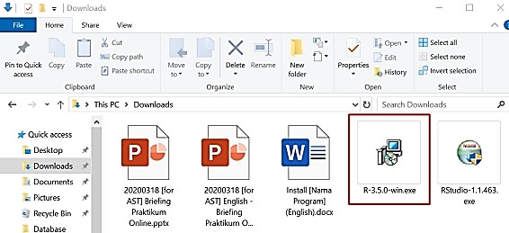

* 1. Select your preferred language (default english) then click OK
  2. Click Next on terms & agreement

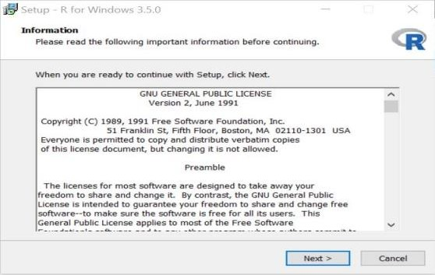

* 1. Select your preferred installation location then click Next

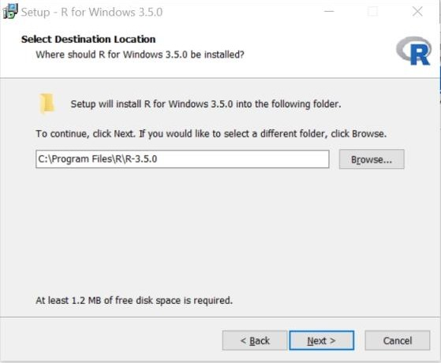

* 1. Click Next on select file to install

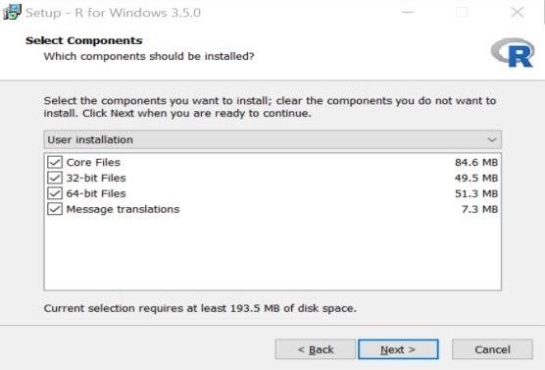

* 1. 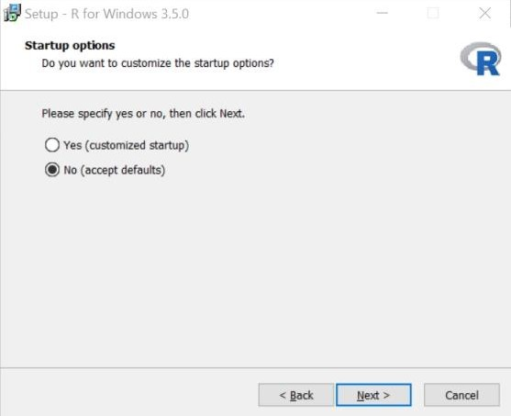Select No to accept the default configuration then click Next

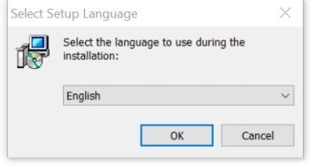

* 1. Click Next

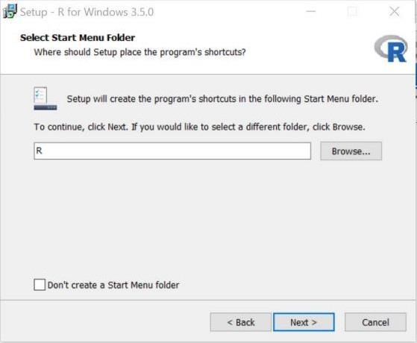

* 1. Select additional task that you want then click Next

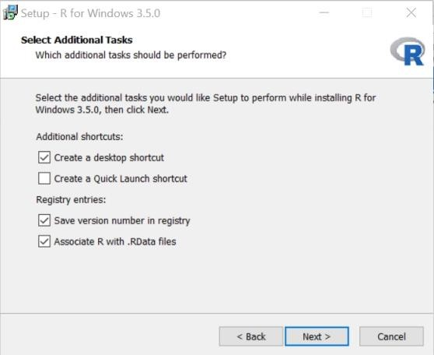

* + 1. Wait the process until completed

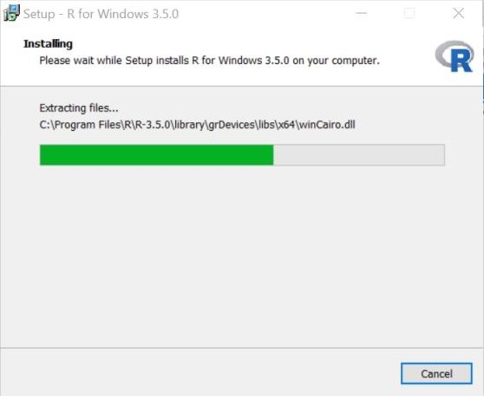

j. Click Finish

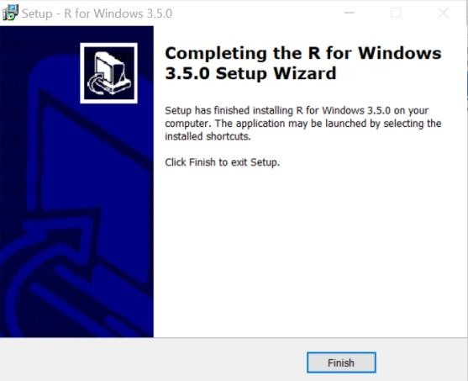

1. *Installing Rstudio 1.1.463 on Windows*
   1. Click on RStudio-1.1.463.exe to start the installer

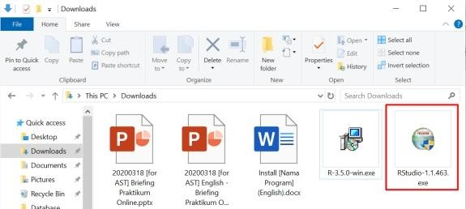

* 1. Click Next

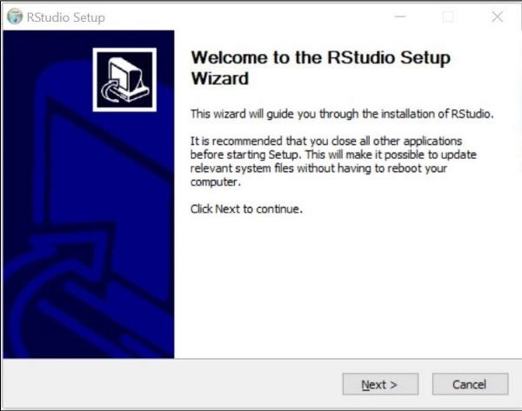

* 1. Select your preferred installation location then click OK

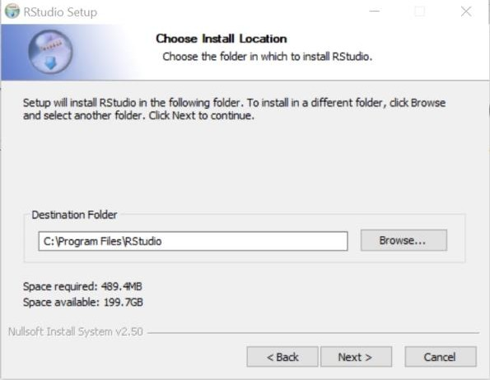

* 1. 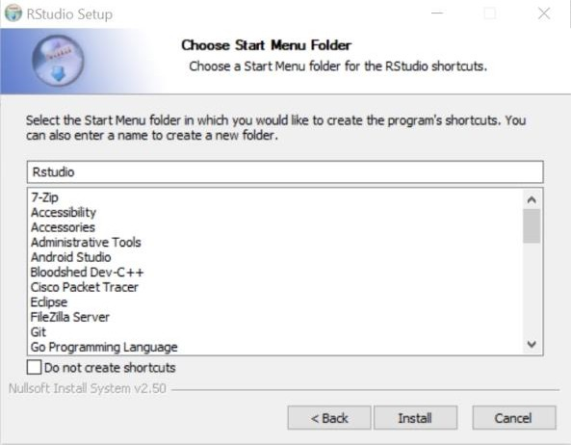Click Next
  2. Wait for the process to complete

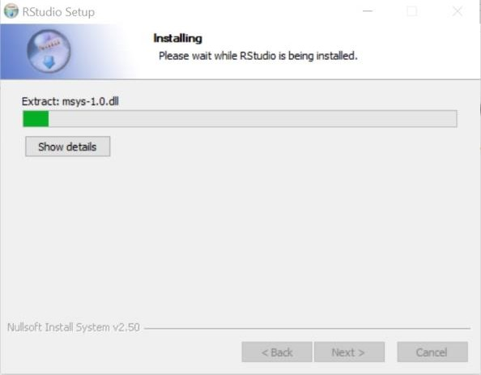

* 1. Click Finish to complete the installation

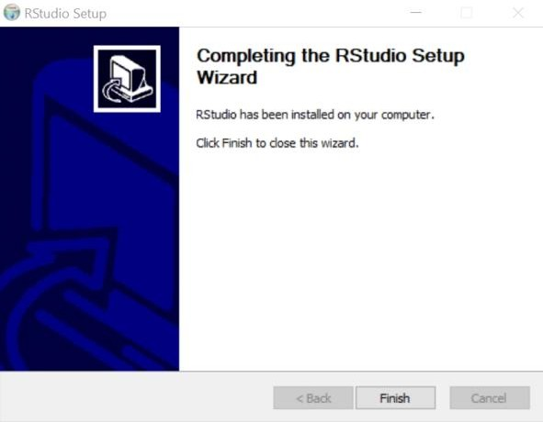

1. *Code Implementation*
2. *DataSet that will be used*

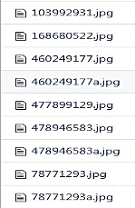

1. *Install Package and Library (Zoom to 350%)*

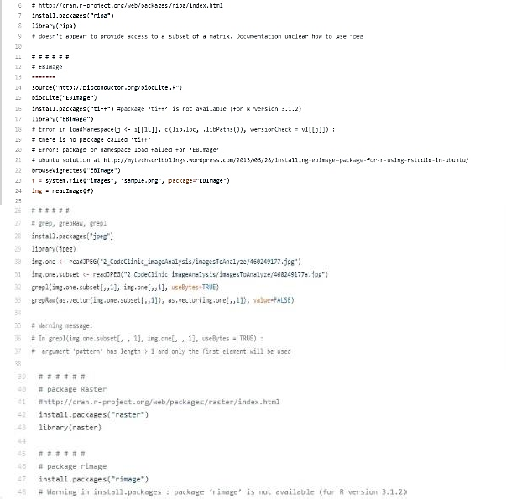

1. *Plotting The Rasters (Zoom to 350% to clear view)*

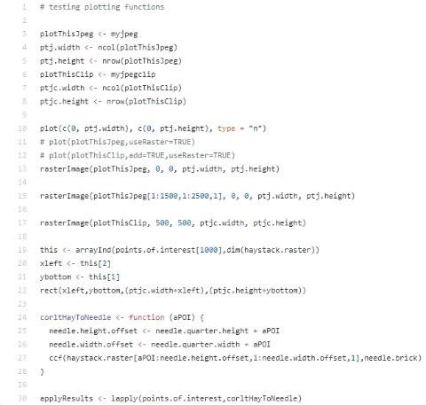

1. *Calculate Cross Correlation (Zoom to 350 %)*

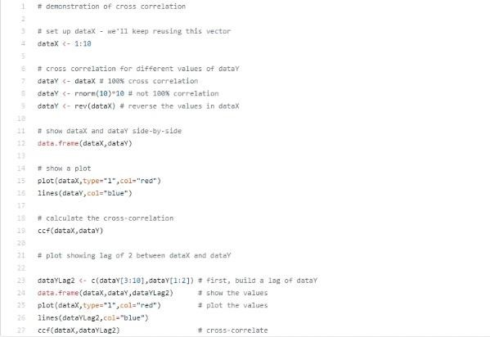

1. 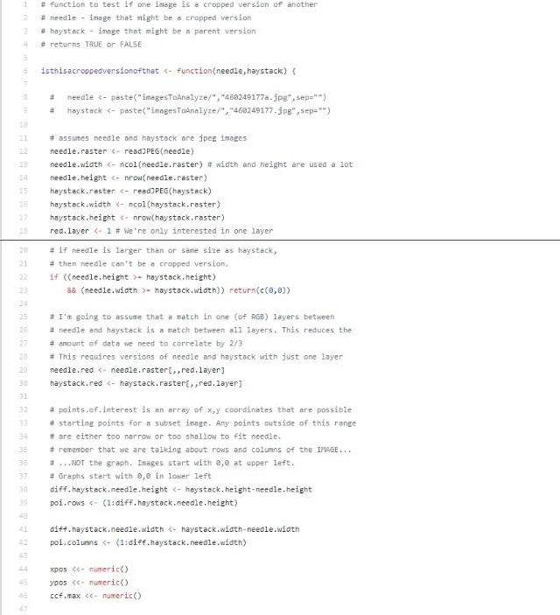*Function to check if a Image is subset of another Image (Zoom to 350% to clear view)*

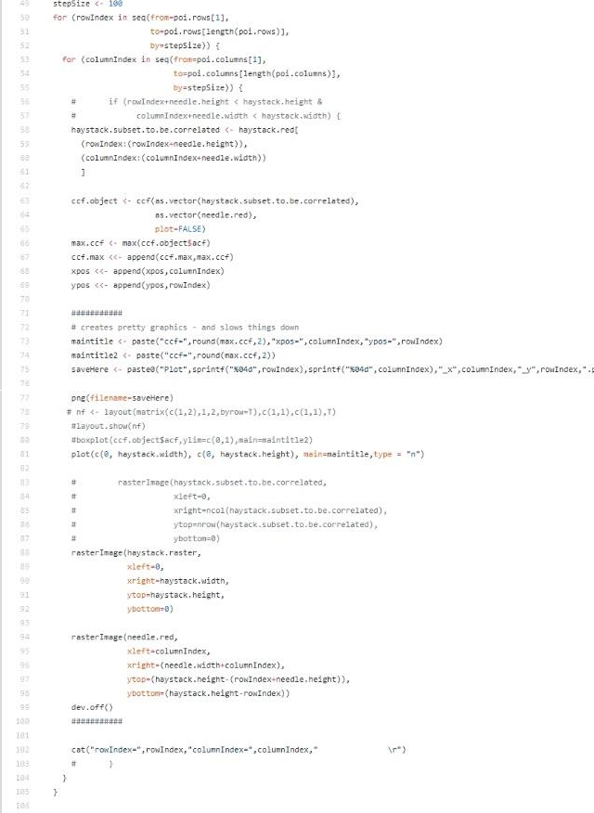

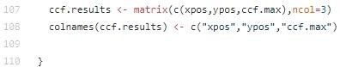

1. *Testing Cod e if Worked or Not Worked (Zoom to 350%)*

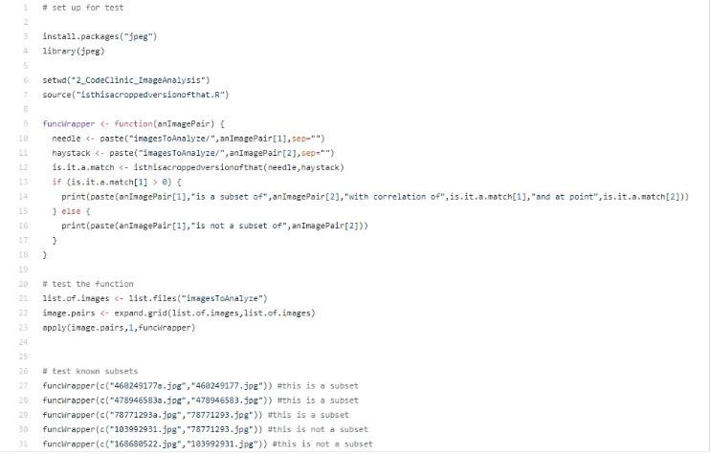

1. *Main Code (zoom to 350%)*

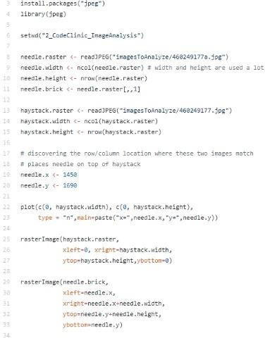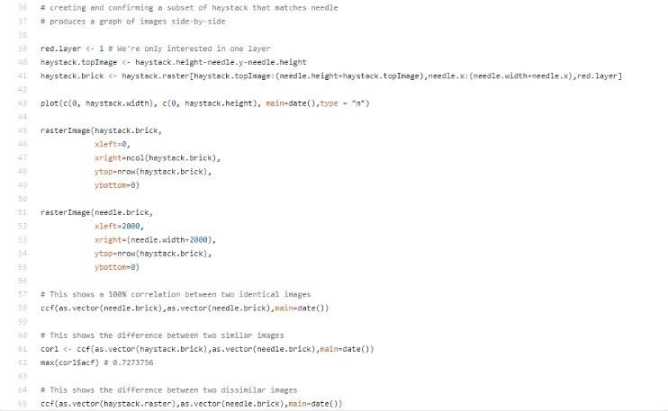

* 1. CONCLUSION

In this technologically advanced world, it has become necessary for the beginners in R and image analysis to learn and understand the things very clearly, so that they could be applied and used in the future. Hence, we have performed the Image analysis tasks in R programming language, so that it becomes easy to all to understand the concepts related to it. This paper also provides the use of R Image Library (RIL), using which we can prominently develop the R based image processing software and can be useful for number of applications like remote sensing, agriculture, space center,

satellites, medical and health sciences, etc. Thus, it can be concluded that R and Image analysis proves to be the better combination for learning, developing and understanding the capabilities provided in it.

REFERENCES

1. Harshada, Ms & Snehal, & Shitole, Sanjay & Pranaya, Mhatre & Suchita, Kadam & Shweta, Ghanate & Kurle, Darshana. (2016). Python Based Image Processing.
2. Mendoza, Fernando & Lu, Renfu. (2015). Basics of Image Analysis. 10.1007/978-1-4939-2836-1_2.
3. Poningsih, Poningsih. (2017). Design of the expert system to analyze disease in Plant Teak using Forward Chaining. International Journal of Artificial Intelligence Research. 1. 11. 10.29099/ijair.v1i1.11.
4. Szegedy, Christian, Wei Liu, Yangqing Jia, Pierre Sermanet, Scott Reed, Dragomir Anguelov, Dumitru Erhan, Vincent Vanhoucke, and Andrew Rabinovich. (2015) "Going deeper with convolutions." In Proceedings of the IEEE conference on computer vision and pattern recognition, pp. 1-9. DOI: 10.1109/CVPR.2015.7298594
5. Su, Hang, Shaogang Gong, Xiatian Zhu, Adrian Popescu, Alexandru Ginsca, Herve Le Borgne, Yuen Peng Loh et al. (2017) "WebLogo-2M: Scalable Logo Detection by Deep Learning From the Web." In Proceedings of the IEEE Conference on Computer Vision and Pattern Recognition, pp. 270-279. DOI: 10.1109/CVPR.2015.7298670.
6. Forder L, Taylor O, Mankin H, Scott RB, Franklin A. (2016) Colour Terms Affect Detection of Colour and ColourAssociated Objects Suppressed from Visual Awareness. Ben Hamed S, ed. PLoS ONE.;11(3):e0152212. doi:10.1371/journal.pone.0152212..
7. Joulan K, Brémond R, Hautière N. (2015) Towards an Analytical Age-Dependent Model of Contrast Sensitivity Functions for an Ageing Society. The Scientific World Journal:625034. doi:10.1155/2015/625034.
8. Nasrollahi, Kamal, Sergio Escalera, Pejman Rasti, Gholamreza Anbarjafari, Xavier Baro, Hugo Jair Escalante, and Thomas B. Moeslund. (2015) "Deep learning based super-resolution for improved action recognition." In Image Processing Theory, Tools and Applications (IPTA), 2015 International Conference on, pp. 67- 72. IEEE. DOI: 10.1109/IPTA.2015.7367098
9. Savioja, Lauri, Akio Ando, Ramani Duraiswami, Emanuel AP Habets, and Sascha Spors. (2015) "Introduction to the issue on spatial audio." IEEE Journal of Selected Topics in Signal Processing 9, no. 5: 767-769. DOI: 10.1109/JSTSP.2015.2447112

# LINK VIDEO PRESENTASI:

<https://youtu.be/rZwOXU359yI>